

Specification

for

SQLdm Reporting

Mark Lauritsen

1/4/07



Proprietary and Confidential to BBS Technologies, Inc.

© 2006 BBS Technologies, Inc.; all rights reserved.

Revision history:
When? | Who? | What?

Table of Contents
1. Revision history: ii
2. Table of Contents iii
3. Requirements 1
3.1. Overview/Purpose 1
3.1.1. Related Customer Requests 1
3.2. Target Users 1
3.3. Feature/Function Market Requirements 1
3.3.1. Required Functions 1
3.3.2. Non-Supported Functions 1
3.4. FAQ 1
3.5. Open Issues 1
4. Functional Design 2
4.1. User Interfaces 2
4.1.1. Root Node 2
4.1.2. Report Nodes 3
4.1.3. Parameters Pane 3
4.1.4. Report Pane 10
4.1.5. Reports 11
4.2. Installation and Upgrade 16
4.3. Permissions and other Required Configuration 16
4.4. Licensing Issues 16
4.5. Dependencies 16
4.5.1. Dependencies on Idera Software 16
4.5.2. Third-Party Software Required on the Customer Machine 16
4.5.3. Third-Party Software Required Internally 16
5. Internal Design 16
5.1. Architecture 16
5.1.1. Stored Procedure Design 16
5.1.2. Differences in Calculations from 4.x 17
5.2. Installation Issues 17
5.3. Schedule 18
5.3.1. Work Breakdown and Sizings 18
5.3.2. Areas of Risk 19
6. Quality Assurance Considerations 19
6.1.1. Overview 19
6.1.2. Developer-Created Unit Tests 20
7. Documentation Considerations 20
8. Bibliography 20

Requirements

Overview/Purpose
This document describes the interface and capabilities of the SQLdm 5.0 (Project Houston) reporting feature.

Related Customer Requests

Target Users

Feature/Function Market Requirements

Required Functions
At a minimum, the reporting feature of SQLdm 5.0 must provide the same functionality as 4.x. The same metrics must be reported. In addition, the query parameters (i.e. time frame and server selection) must be shared by all reports (whenever feasible) so the user doesn’t have to re-specify the parameters for each report.

Non-Supported Functions
The user will not be able to specify individual metrics.
The user will not be able to create custom reports.

FAQ

Open Issues

Functional Design

User Interfaces

Root Node
The navigation pane of the Desktop Client will contain a list of nine pre-defined reports as seen in the following screen shot. The view (right) pane changes according to which node is selected. When the root Reports node is selected, the view displays a summary of the available reports. Clicking on a report name in this view navigates to the corresponding report (equivalent to clicking a child node in the navigation pane).
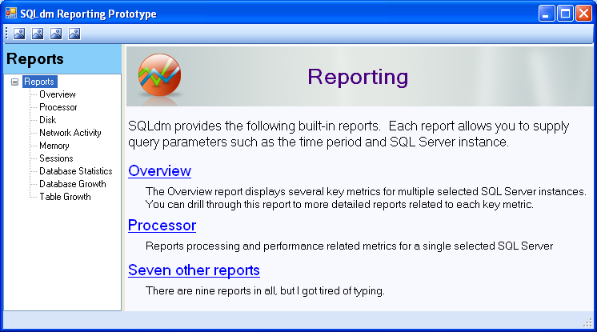

Report Nodes
The nine child nodes display a report pane on bottom and a parameters pane on top as seen in the following screen shot (disregard the “Sample Report” node and pretend the nine reports are listed in the tree instead ☺). The parameters pane can be hidden and shown by clicking a toolbar button. The user must specify the required parameters and click the “View Report” button before the report will appear in the report pane. Until then, the report pane will display an explanatory message such as “To view the report please specify the required parameters and click View Report.”
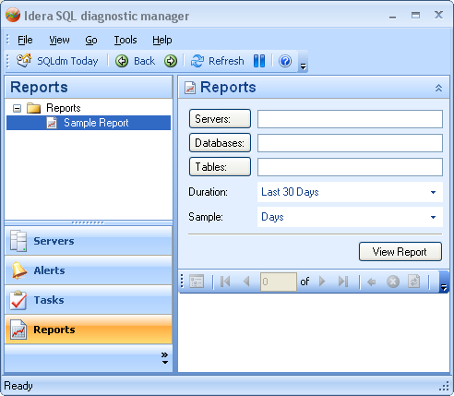

Parameters Pane
Depending on the report currently selected in the navigation pane, the Tables and possibly the Databases controls will be disabled or hidden (TBD). There are four types of reports described below.
- Multi-server: The Overview report is the only multi-server report. It allows multiple servers to be selected. It does not allow databases or tables to be selected, so these controls are hidden.
- Single server: Most reports allow only one server to be selected. The Databases and Tables controls will be hidden.
- Multi-database: Some reports allow multiple databases (but no tables) to be selected in addition to a single server. The Tables control will be hidden.
- Multi-table: One report (Table Growth) allows multiple tables to be selected in addition to a single server and single database. Since this is the worst case (most controls), this case was chosen for the mock-up of the parameters pane seen above.
To conserver space in the parameters pane, selection lists of available items (servers, databases, or tables) are not displayed inside the pane. The user can type the names of these parameters directly into the text boxes if desired. These parameters also have buttons that launch an appropriate dialog for each parameter. These dialogs are discussed in the following sections.

Servers Dialog
This is simply a list of registered SQL Server instances. If the Overview report node is currently selected, the list will support multi-select. Otherwise it will be single-select.
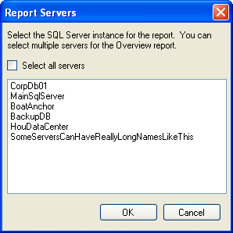

When the user returns from this dialog, the selected servers will be listed in the parameters pane as seen in the following screen shot. If the list extends past the right end of the text box, the text box will grow vertically up to three lines tall with a scroll bar if needed.
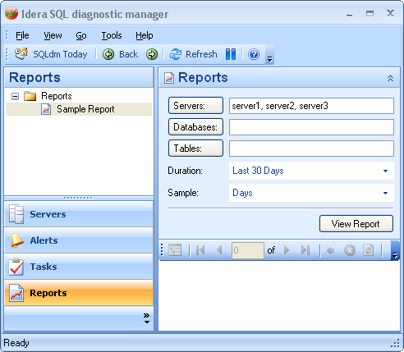

Databases Dialog
The Databases dialog looks exactly like the Tables dialog except it contains a list of databases for the currently selected server. The list will either be single-select or multi-select depending on which report node is currently selected. When the user returns from this dialog, the selected tables are listed in the Tables control on the parameters pane similar to how the selected servers are listed.

Tables Dialog
The Tables dialog contains a multi-select list of tables for the currently selected server+database. System tables are grouped separately from user tables. Radio buttons are provided for selecting all user tables, all system tables, all tables, or individual tables.
When the user returns from this dialog, the selected tables are listed in the Tables control on the parameters pane similar to how the selected servers are listed.
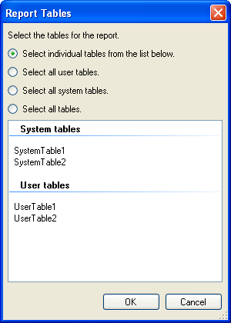

Duration Control and Dialog
The Duration control seen in the parameters pane allows the user to select the time span or range covered by the report. It is a drop-down list containing the following options.
- Today
- Last Work Week
- Last 7 Days
- Last 30 Days
- Last 365 Days
- Custom
The “Custom” option launches the Duration dialog (below) which allows the user to select arbitrary days, months, and years (not necessarily contiguous) as well as a contiguous range of dates. It displays different controls depending on which of those options is chosen via the radio boxes. The following four screen shots show all four possibilities.
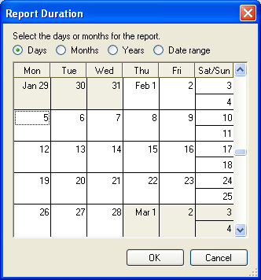
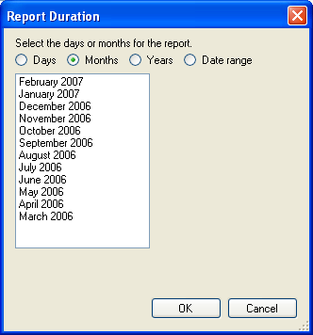
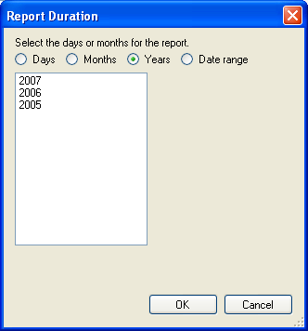
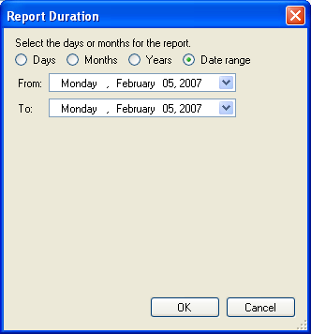
When the user returns from this dialog, the selected days, months, years, or range will be listed in the Duration control on the parameters pane similar to how the servers are listed after returning from the Servers dialog in the next section.

Sample
The Sample control is drop-down containing the following options.
- Minutes
- Hours
- Days
- Months
- Year
This controls the granularity of the report. For example, if Hours is selected, each point on the charts in the report will represent one hour’s worth of data. If Days is selected, each point will represent a day, resulting in fewer points on the charts.
The above options will not all appear at the same time. A subset of the options will appear depending on what is currently selected for the Duration. For example, if the user has selected a list of days for the Duration, it does not make sense to allow Months or Year for the Sample parameter.

Report Pane
Once the report has been generated the user will probably want to hide the parameters pane by clicking the “Hide Parameters” button. The result looks like this.
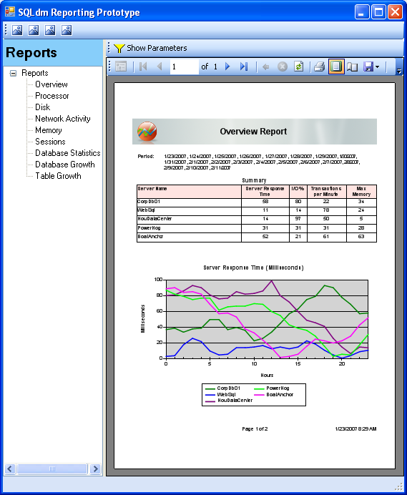
The report seen above was generated with the ReportViewer control, which has some important features we can leverage.
- ReportViewer has a feature called “drill through” that allows various elements on the report to be linked to other reports. E.g. the user can click a server name to view more details about that server.
- The report is sized and formatted with printing in mind.
- ReportViewer has built in support for printing, exporting the report to PDF and Excel, paging, and scaling. These features are accessible via the control’s built in toolbar. This is expected to save development time.

Reports

Overview Report
The Overview report is the only multi-server report. That is, the user can select multiple servers to report on. Refer to the previous screen shots in which five servers have been selected. The report shows certain key metrics for the selected servers. It is divided into these three areas.

Duration
This area reflects the user’s choices for the Duration parameter. If the user selects a continuous range of days or months, the duration will be shown as a range like “1/10/2007 – 1/21/2007”. If the user selects a discontinuous set of days or months, the duration will be shown as a list.

Summary
This is a table showing the last value returned for some of the metrics for each selected server. There is not enough page width to show values for all seven metrics that have charts on the report.

Charts
The rest of the report consists of charts. Each metric has a chart with a data series for each server. Each series is linked to a sub-report that contains additional metrics related to that series’ metric and server. That is, by clicking on one of its chart lines, the user navigates to a more detailed report. The detailed reports can also be accessed via the navigation pane.

The following metrics have charts on the Overview report.

Server response time | Links to the Processor sub-report
I/O % | Links to the Disk sub-report
Network packets per minute | Sum of packets received, packets sent, and errors per minute. Links to the Network Activity sub-report.
Max memory used | Links to the Memory sub-report.
User processes | Links to the Sessions sub-report
Transactions per minute | Aggregate for all databases. Links to the Databases sub-report.
Size | Sum of all database sizes. Links to Database Growth sub-report.

Processor Report
This report displays the following metrics for a single server.
- Server response time in milliseconds
- Cpu %
- SQL compilations per minute
- SQL recompilations per minutes
- Table lock escalations per minute
- Lock waits per minute
- Processor activity (from OS statistics)
  - Privileged time %
  - User time %
  - Processor time %
- Processor queue length (from OS statistics)

The first page of the Processor report is shown below. The layout differs from the Overview report in that server name appears under the Period area and there is no table (just charts). Though not shown in the screen shot, charts with one metric will plot both the average value for each sample (e.g. hour) and the max or min as appropriate. The only chart in the Processor Report with multiple metrics is the Processor Activity chart (see the list above) which will have a legend to identify the three metrics that appear on that chart.

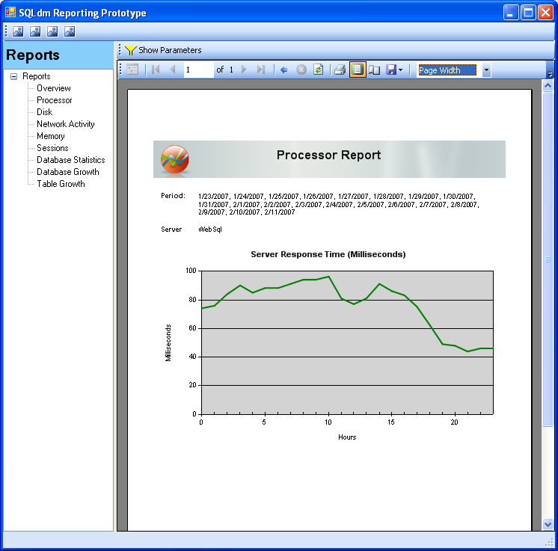

Disk Report
  - I/O %
  - Physical disk activity per minute
    - Page reads
    - Errors
    - Lazy writer writes
    - Checkpoint writes
    - Log writes
  - Work files created per minute
  - Read ahead pages per minute
  - Page splits per minute
  - Max page life expectancy
  - Page lookups and requests per minute
  - Maximum TempDB size in percent
  - Maximum TempDB size in kilobytes
  - Pages per second (from OS statistics)
  - Disk time % (from OS statistics)
  - Disk queue length (from OS statistics)

Network Activity Report
Network Activity packets per minute
Received
Sent
Errors

Memory Report

- Memory usage in megabytes
    - Max memory allocated
    - Max memory used
- Maximum procedure Cache Size in megabytes
- Maximum procedure cache size in percent
- Buffer cache hit ratio percentage
- Procedure cache hit ratio percentage
- Work tables created per minute
- Memory usage in megabytes (from OS statistics)
    - Available memory
    - Total memory

Sessions Report
Logins including unsuccessful
User processes
Maximum User Processes
Maximum Client Computers
Transactions per minute
Oldest open transactions in minutes
Replication max latency period in seconds
Replication statistics
Max unsubscribed
Subscribed
Max nondistributed

Databases Report
This is a multi-database report. Each metric has its own chart with a series for each currently selected database. All databases are selected the first time this report is viewed for a given server. The user can select specific databases via the filter dialog. The user’s selection is persisted and reused the next time this report is viewed

- Transactions per minute
- Log flushes per minute
  - Log flush waits
  - Log flushes
- Log Kilobytes flushed per minute
- Log cache reads per minute
- Log cache hit ratio

Database Growth Report
This is a multi-database report. Each metric has its own chart with a series for each currently selected database. Initially, all databases are selected. User can pick a subset via the filter dialog. User’s selection is persisted across executions. This report has a sub-report called Table Growth that shows table-level statistics for whatever database the user clicks on (regardless of metric).

- Growth%
- Size
- Data size
- Data size allocated
- Index size
- Log size
- Log size allocated
- Text size

Table Growth Report
This report is a sub-report of the Database Growth report. It displays growth statistics for one or more tables in a single database (selected by drilling through the Database Growth report). All tables are selected the first time this report is viewed for a given database. The user can select specific tables via the filter dialog. The user’s selection is persisted and reused the next time this report is viewed
  - Growth%
  - Size
  - Row growth%
  - Number of rows
  - Data size
  - Index size
  - Text size
  - Reorg %

Installation and Upgrade

Permissions and other Required Configuration

Licensing Issues

Dependencies

Dependencies on Idera Software

Third-Party Software Required on the Customer Machine

Third-Party Software Required Internally

Internal Design

Architecture

Stored Procedure Design
The data for the reports is obtained directly from the Repository database (as opposed to calling the Management service). Several stored procedures will be written to facilitate data retrieval for reporting. One stored procedure will be provided for each of the reports. These procedures will return data across the appropriate time range as calculated to the selected time interval for each of the selected servers. The procedures will utilize XML to allow for multi-selects across both server and timeframes. The supported intervals for data retrieval will be Minute, Hour, Day, Month, and Year.
Procedure Arguments (preliminary):
@XmlDocument (optional) – XML representation of list of SQL Servers and list of time periods
@Interval (default minute) – tinyint representation of the time interval on which to calculate the data
@StartTime (optional) – datetime representing the earliest data allowed
@EndTime (optional) – datetime representing the latest data allowed
Procedure Output (preliminary):
CollectionDate – Maximum datetime in the roll-up interval
InstanceName – SQL Server instance name
One column for each of the report metrics

Differences in Calculations from 4.x
In DM 4.x the maximum granularity for any data point was 10 minutes, so all data calculations were based on the assumption that there would be exactly 6 data points per hour. Setting a collection interval beyond 10 minutes exposed an issue in the way that data was calculated for graphs and could result in erroneous data display, and setting a collection interval less than 10 minutes caused data to be overwritten. In Project Houston the granularity is unlimited, and for this reason the calculations cannot be based on the 6 data point assumption. Instead, calculations will be weighted to timeframe. For this reason, data from DM 4.x and Project Houston may not match even on the same interval and with the same values recorded.
Example:
Collection Start – 12:03:00 PM
Data Point 1 – 12:09:00 PM – CPU Utilization 35%
Data Point 2 – 12:15:00 PM – CPU Utilization 48%
Data Point 3 – 12:21:00 PM – CPU Utilization 23%
Data Point 4 – 12:28:00 PM – CPU Utilization 52% *Note that collection took a minute longer here
Data Point 5 – 12:34:00 PM – CPU Utilization 13%
Data Point 6 – 12:40:00 PM – CPU Utilization 27%
Data Point 7 – 12:46:00 PM – CPU Utilization 35%
Data Point 8 – 12:52:00 PM – CPU Utilization 42%
Data Point 9 – 12:58:00 PM – CPU Utilization 36%
Data Point 10 – 1:03:00 PM – CPU Utilization 27% *Note that the 10th collection did not fall within the hour
DM 4.x Calculation – The data is written for each 10 minute period, which means that data points 2, 6, and 8 are overwritten and point 10 is ignored for the 12:00 hour.(35 + 48 + 52 + 13 + 35 + 36 ) / 6 = 36.5%
DM Project Houston Calculation – The data is weighted for the length of time in seconds covered by the metric. Data point 10 is still ignored for this hour.
((35 * 360) + (48 * 360) + (23 * 360) + (52 * 420) + (13 * 360) + (27 * 360) + (25 * 360) + (42 * 360) + (36 * 360) ) / 3300 = 34.7%

Installation Issues
Insert changes for installation – new files to be dropped, new configuration screens etc. Think about the initial install and upgrade cases.

Schedule

Work Breakdown and Sizings
Insert areas that put the implementation or schedule at risk – Assumptions made in design, new areas that have a learning curve etc. Break the project into logical components and add time for design, coding, integration, unit testing. These estimates should not take into account outside forces like maintenance work. These will be applied in building the overall project schedule. A general rule of thumb is to break any unit of work greater then 1 week into smaller pieces to ensure accuracy and to allow measurement of progress during the project.
Component | Who | Sizing
UI: root node view | Mark | 6 hours
UI: Two-pane view for child nodes (with hide/show of top pane) | Mark | 4 hours
UI: Navigation pane | Mark | 3 hours
UI: Parameter pane for multi-server (first one to be implemented) | Mark | 10 hours
UI: Parameter pane for single server | Mark | 4 hours
UI: Parameter pane for multi-database | Mark | 4 hours
UI: Parameter pane for multi-table | Mark | 4 hours
UI: Build dataset for passing parameters to stored procs | Mark | 3 hours
UI: Custom control for multi-select drop-down selection | Mark | 4 hours
UI: Drill-through | Mark | 4 hours
UI: Calling stored procedures | Mark | 2 hours
UI: Overview report (only multi-server report) | Mark | 8 hours
UI: Processor report (first single-server report) | Mark | 6 hours
UI: Disk report (single-server report) | Mark | 3 hours
UI: Network Activity report (small single-server report) | Mark | 2 hours
UI: Memory report (single-server report) | Mark | 3 hours
UI: Sessions report (single-server report) | Mark | 3 hours
UI: Database report (first multi-database report) | Mark | 6 hours
UI: Database Growth report (multi-database) | Mark | 3 hours
UI: Table Growth report (only multi-table report) | Mark | 6 hours
UI: Total | Mark | 88 hours
Repository: Overview report (first to be implemented) | Vicky | 8 hours
Repository: Processor report | Vicky | 1 hour
Repository: Disk report | Vicky | 1 hour
Repository: Network Activity report | Vicky | 1 hour
Repository: Memory report | Vicky | 1 hour
Repository: Sessions report | Vicky | 1 hour
Repository: Database report (first multi-database report) | Vicky | 6 hours
Repository: Database Growth report | Vicky | 1 hour
Repository: Table Growth report (only multi-table report) | Vicky | 6 hours
Repository: Total | Vicky | 26 hours
Unit and Integration Testing | Vicky | 8 hours
Unit and Integration Testing | Mark | 16 hours
Total |  | 138 hours

Areas of Risk
There are many types of risks. For example, a section might describe
- Areas with big learning curve
- Design assumptions that still need to be proven
- a technical hurdle that needs to be overcome.
- An area which has many unknowns
- Outcomes of other plans/implementations which could affect the deliverability of this feature.
Where possible, each section should explain the risk, quantify the risk, enumerate possible actions to address the risk, and recommend the action that is appropriate.

Quality Assurance Considerations

Overview
Insert explanations for QA considerations that are not apparent from the rest of the specification. Include things like tests on platforms that you want run in greater width then a developer can easily do or which tests you would want as an acceptance test each time a release goes out the door.
This section should identify all the testing activity that should be performed to verify the project has:
- Satisfied the completion criteria
- Works consistently with the existing components or works at least as well as the component being replaced
- No other components have lost functionality or no longer work
- Meets the standards as defined and approved by this document
- Identifies all the edit rules for each data element in the process

Developer-Created Unit Tests
Automated, Developer-Created Unit Tests which will be Created (and Passed to QA)
Developer Tests which will be Manually Performed

Documentation Considerations

Bibliography

